ANDREW BROWNE

‘SIXTEEN FIGMENTS’
# 1 – 16

_______________________________________________________________

‘Figment’ refers to the fiction, fabrication and falsehood of these images, and their place in the imaginary realm… though most appear as reasonably straightforward photographs of various commonplace, even banal subjects in somewhat moody lighting, they are in fact carefully manipulated for dramatic - even theatrical - effect. Each image then is an act of creation, not unlike fictional short stories, filmic and noirish yet resistant of simple analysis. Rather, each presents curious forms and juxtapositions, some the evidence of odd, cryptic or nefarious actions or behaviours, as though contrived to confound or irritate and yet all inescapably the result of human intervention.

This group is not intended to be read in a sequence or as a cumulative narrative, yet each discreet image contains enough to imagine a complex back story of some kind, even if a present meaning or indeed ‘use’ of such images/objects remains opaque… their possible resonance, value and connections a creation (figment) of each individual mind.

_

The majority of these photographs were shot in and around Newport and the inner urban West, with the exception of a handful from other urban locales dropped in for dramatic effect! As such, they variously depict the accumulation of years of human activity and best intentions… (now) obscure and even bittersweet attempts at manipulating landscapes and objects.

_______________________________________________________________

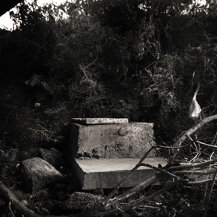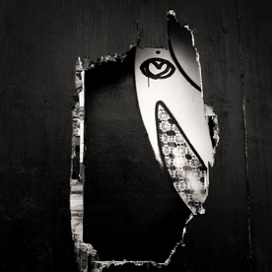

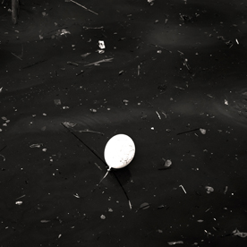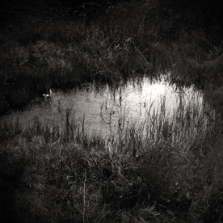

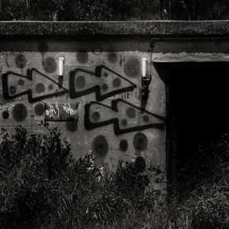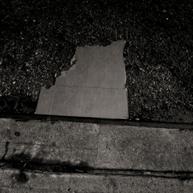

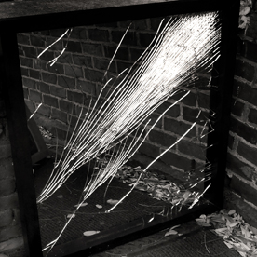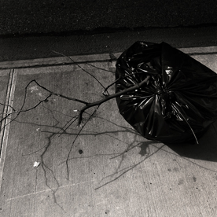

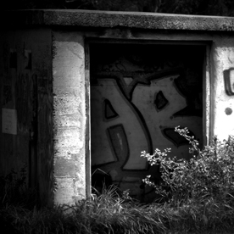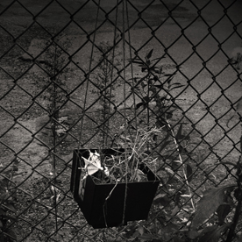

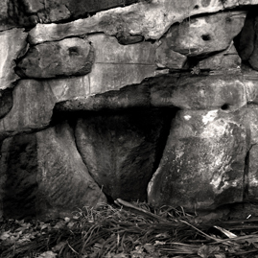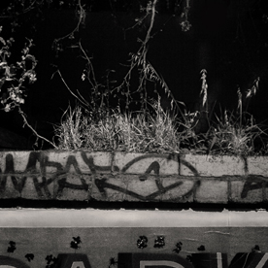

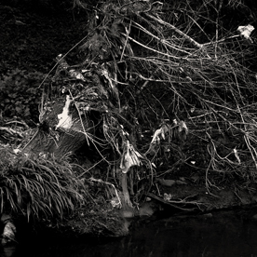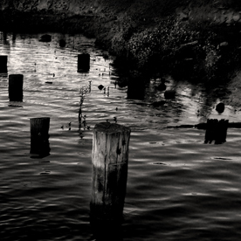

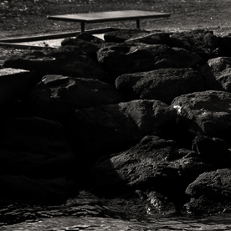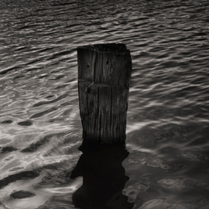

ANDREW BROWNE

‘SIXTEEN FIGMENTS’
# 1 – 16

Suite of sixteen digital photographs on Canson Rag Photographique 310 gsm

Edition of 5 + 1A/P

Image size 280 x 280 mm
Paper size 500 x 400 mm

2012

Printed by Chris Pennings at JCP Studios, Prahran

Courtesy the artist and Tolarno Galleries

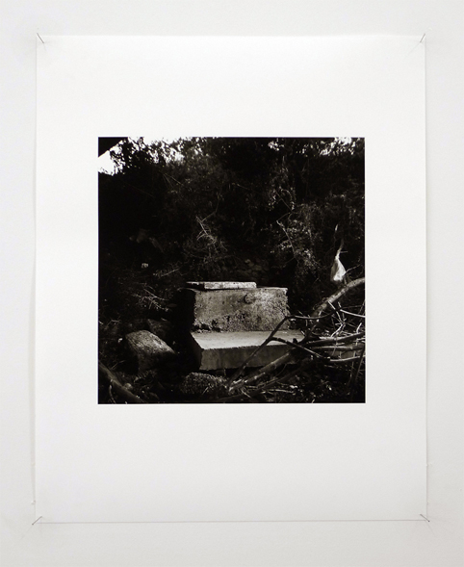

Sheet example

